GoodSecurity Penetration Test Report

[SidneyRobinson@GoodSecurity.com](mailto:SidneyRobinson@GoodSecurity.com)

10/24/2021

# High-Level Summary

GoodSecurity was tasked with performing an internal penetration test on GoodCorp’s CEO, Hans Gruber. An internal penetration test is a dedicated attack against internally connected systems. The focus of this test is to perform attacks, similar to those of a hacker and attempt to infiltrate Hans’ computer and determine if it is at risk. GoodSecurity’s overall objective was to exploit any vulnerable software and find the secret recipe file on Hans’ computer, while reporting the findings back to GoodCorp.

When performing the internal penetration test, there were several alarming vulnerabilities that were

identified on Hans’ desktop. When performing the attacks, GoodSecurity was able to gain access to his machine and find the secret recipe file by exploiting two programs that had major vulnerabilities. The details of the attack can be found in the ‘Findings’ category.

# Findings

Machine IP:

192.168.0.20

Hostname:

MSEDGEWIN10

Vulnerability Exploited:

Searchsploit Icecast

Vulnerability Explanation:

Open Port: 8000 /tcp running service: Icecast Streaming Media Server

This vulnerability allows remote user access to the windows shell. The exploit causes a header buffer overflow on TCP port 8000. The exploit utilizes Icecast media streaming to overwrite the end of a pointer array when a machine is receiving 32 HTTP headers.

Severity:

Medium level severity

Proof of Concept:

Open Ports and running services:

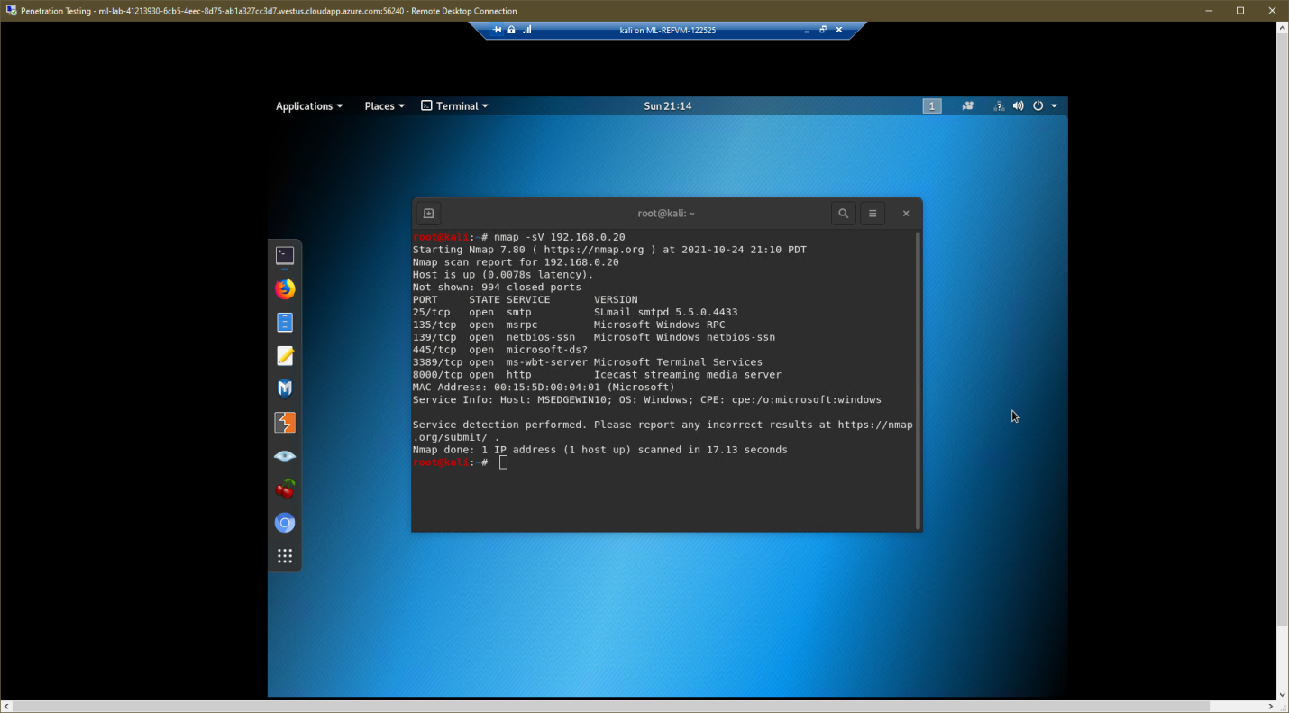

Exploit-DB search for possible Icecast exploits:

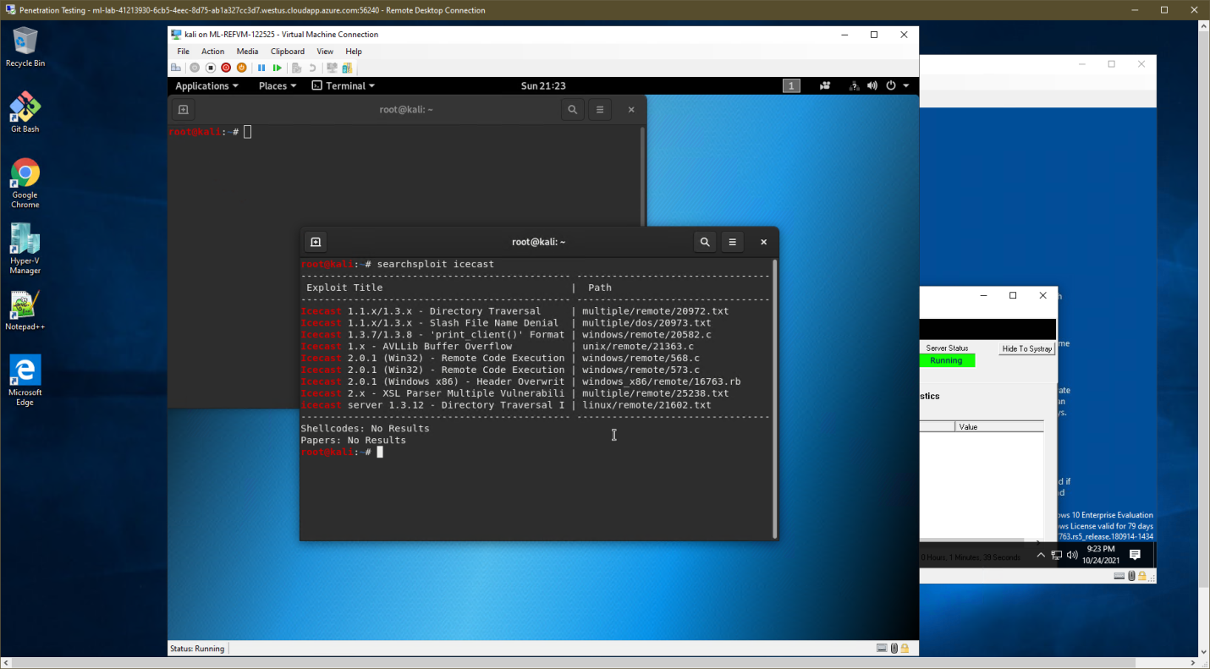

Run Metasploit console, search for available Icecast exploits and use Metasploit to gain Metepreter access to ftp system on MSEDGEWIN10 machine at 192.168.0.20:

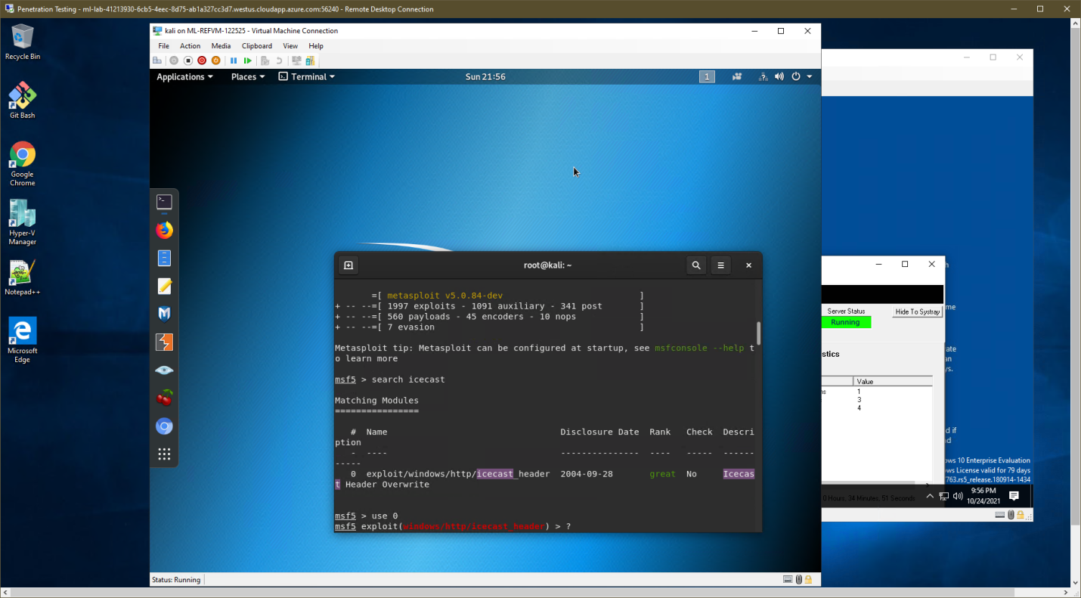

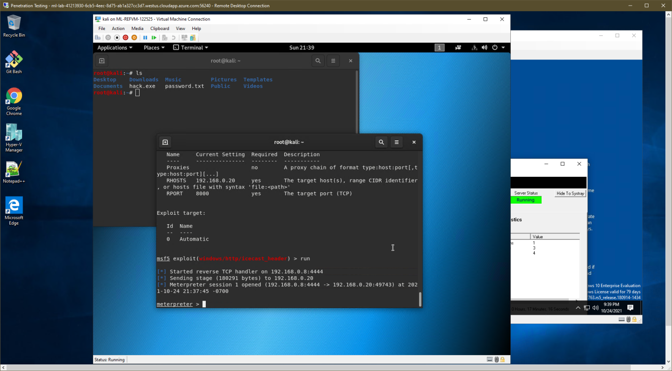

Finding and exfiltrating secret and recipe target files:

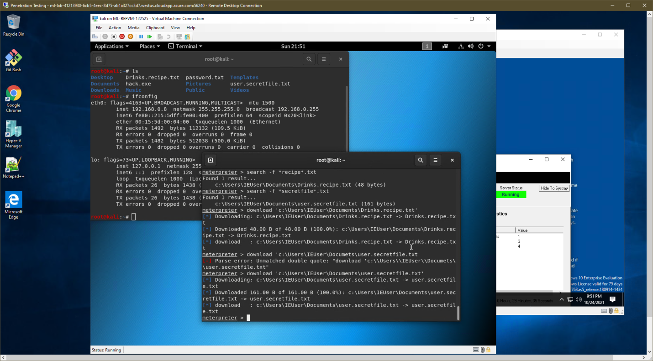

Run Meterpreter local_exploit_suggester to find additional possible exploits that can be used against the MSEDGEWIN10 machine at 192.168.0.20:

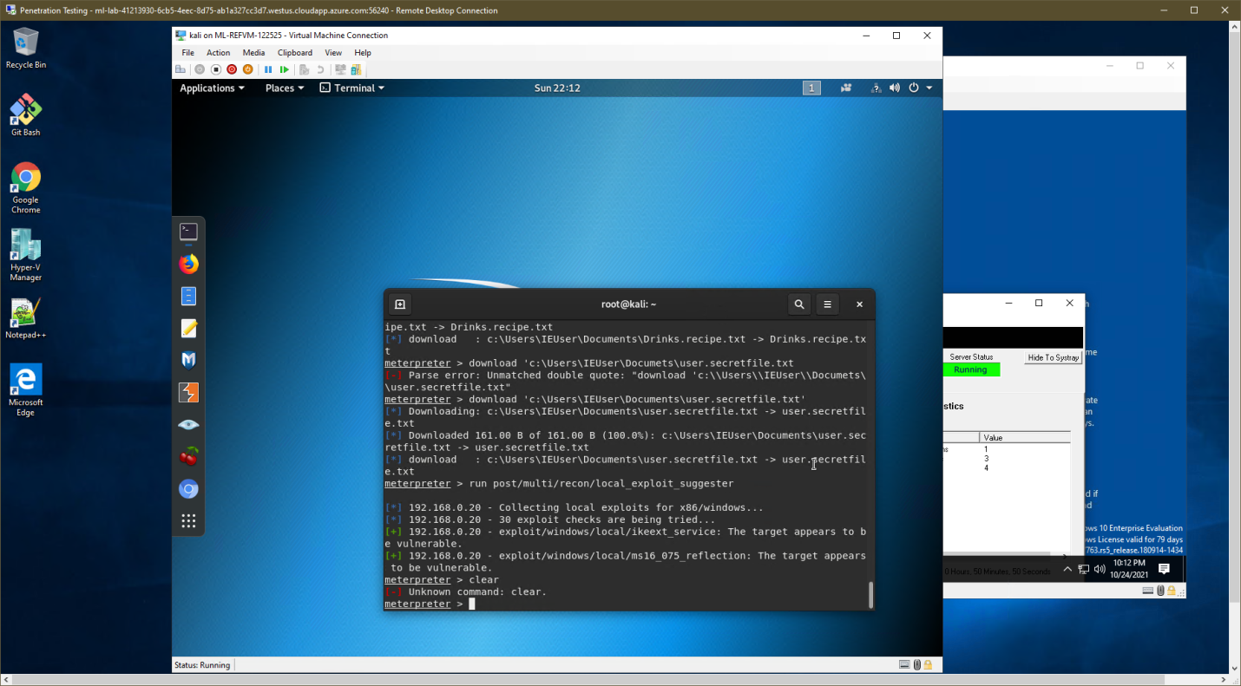

Meterpreter reports additional vulnerable exploits: ikeext_service and ms16_075_reflection (above).

Ikeext_service – this exploit uses an insecure bin path to plant a DLL payload. This payload is used to exploit a missing DLL loaded by the IKE and AuthIP Keyring Modules (IKEEXT), a service that runs and auto-starts with SYSTEM credentials.

ms16_075_reflection – this exploit uses Net-NTLMv2 reflection to create a SYSTEM handle between DCOM and RPC that elevates privileges. If you have exploited your way to a shell you can use incognito to impersonate the token.

Enumerating logged on MSEDGEWIN10 users with Meterpreter :

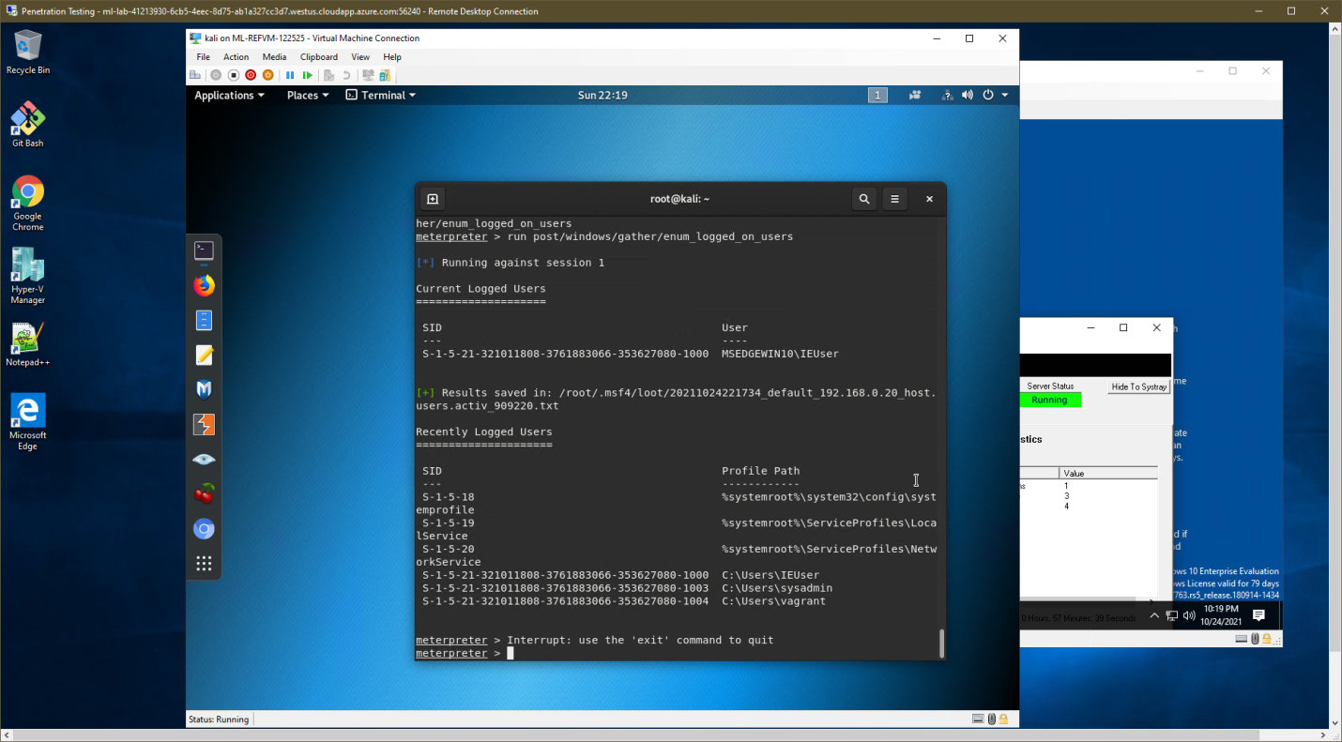

Opening a shell into MSEDGEWIN10 and listing the system information:

